1. Calculate pricing for a client who wants migration there existing workload to AWS Mumbai Region, the existing setup includes:

Load Balancer

Web Server (Qty:4, CPU:2, RAM: 8GB, Storage: 20 GB )

App Server (Qty:4, CPU:2, RAM: 8GB, Storage: 20 GB)

Database Server (Qty: 1 Master and 1 Replica, CPU:2, RAM: 16GB. Storage: 50 GB)

Monthly Data Transfer Out: 100 GB

[https://calculator.s3.amazonaws.com/index.html#r=BOM&key=calc-532C0F6B-F8E6-4CFC-A377-E9E2AA35799E](https://calculator.s3.amazonaws.com/index.html" \l "r=BOM&key=calc-532C0F6B-F8E6-4CFC-A377-E9E2AA35799E)

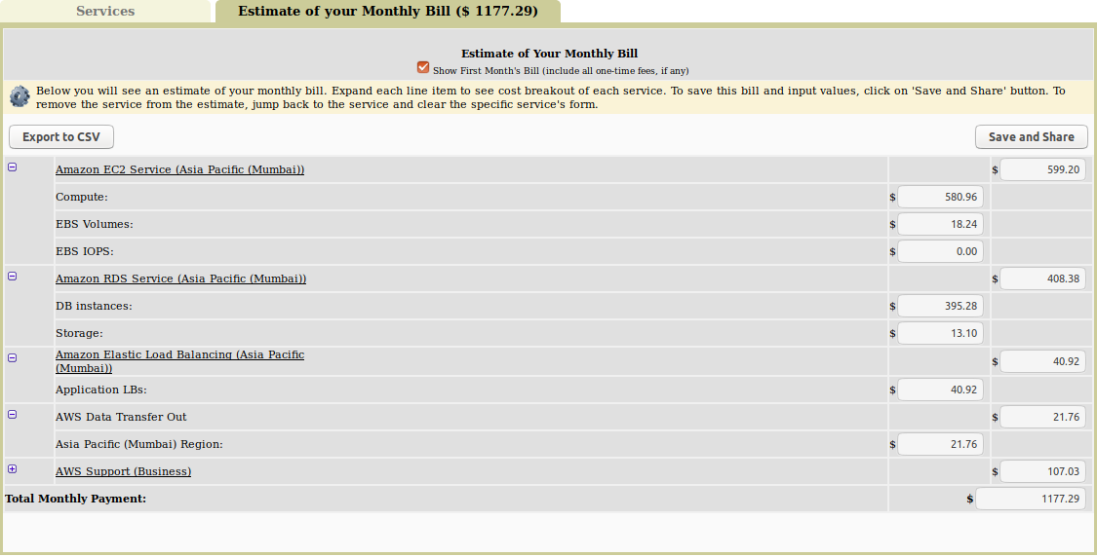

2. Calculate pricing for a client who wants migration the QA workload to AWS Mumbai Region, the existing setup includes:

Load Balancer

Web Server (Qty:10, CPU:2, RAM: 8GB, Storage: 20 GB )

Database Server (Qty: 10 Master, CPU:2, RAM: 16GB. Storage: 50 GB)

Monthly Data Transfer Out: 100 GB

The stack remains operational only for 8 days per day

[https://calculator.s3.amazonaws.com/index.html#r=BOM&key=calc-ED617B2B-769D-4ABE-A691-DF56B9028BBE](https://calculator.s3.amazonaws.com/index.html" \l "r=BOM&key=calc-ED617B2B-769D-4ABE-A691-DF56B9028BBE)

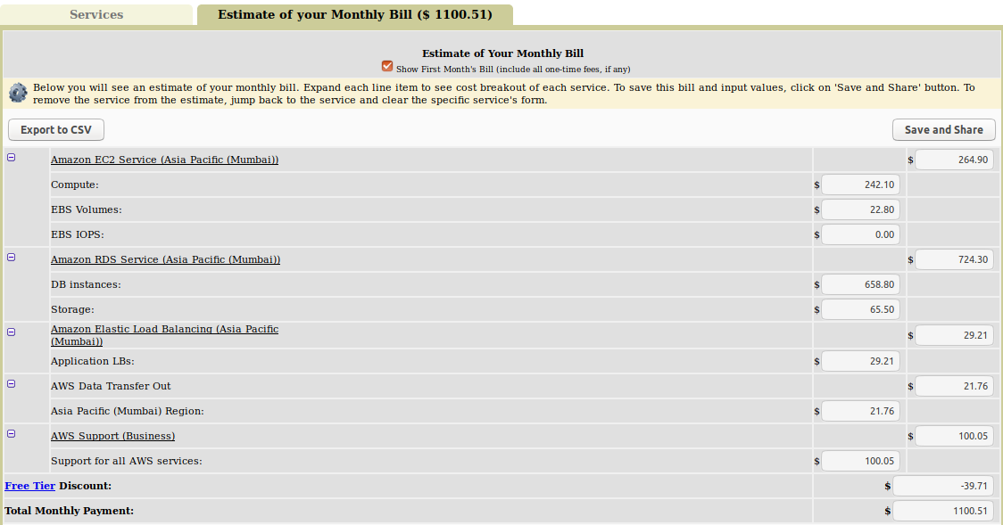

3. Define the use cases where you will recommend using On demand, Reserve Instances (Standard & Convertiable) and Spot instances

Also calculate the 1 year no upfront pricing for the production environment (1 Question)

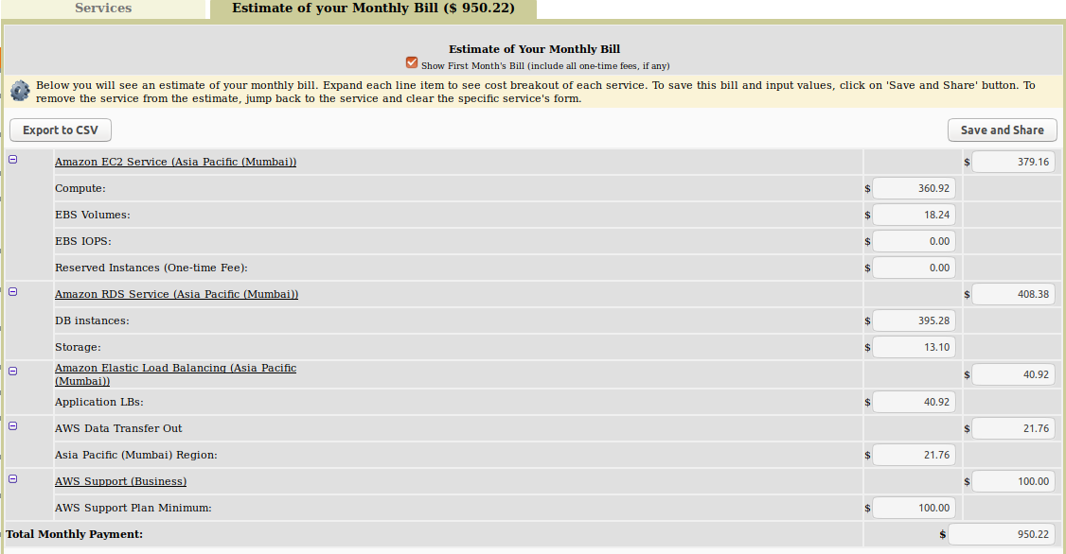

[https://calculator.s3.amazonaws.com/index.html#r=BOM&key=calc-476A8712-C891-4FFE-B92F-747FC5ABD52B](https://calculator.s3.amazonaws.com/index.html" \l "r=BOM&key=calc-476A8712-C891-4FFE-B92F-747FC5ABD52B)

On Demand = AWS recommends using On-Demand Instances for applications with short-term, irregular workloads that cannot be interrupted. They are also suitable for use during testing and development of applications on EC2. On-Demand Instances have no contract commitment and can be launched as needed -- except potentially during periods of very high compute demand in particular availability zones.

Spot=You can use Spot Instances for various fault-tolerant and flexible applications. Examples include web servers, API backends, continuous integration/continuous development, and Hadoop data processing.

You can also take advantage of Spot Instances to run and scale applications such as stateless web services, image rendering, big data analytics, and massively parallel computations. Spot Instances are typically used to supplement On-Demand Instances, where appropriate, and are not meant to handle 100% of your workload.

Reserved = AWS **Reserved Instances** (Amazon **Reserved Instances**) are virtual servers that run in Amazon Web Services' Elastic Compute Cloud (EC2) and Relational Database Service (RDS). The companies purchase the **instances** at contract prices, plus hourly rates. **Instances** are available in varied levels of compute power.